EXPT NO:4 | TRANSFORM DATA TO SUIT BI REPORTING REQUIREMENTS AND  DESIGN A DASHBOARD WITH KEY PERFORMANCE INDICATORS (KPIs) USING TABLEAU AND POWERBI
DATE: 24.07.2026

PRE-LAB QUESTIONS (PROVIDE BRIEF ANSWERS TO THE FOLLOWING QUESTIONS)
- What is the role of data transformation in BI reporting?
Data transformation is the process of converting raw data into a clean and organized format for analysis. It includes changing data types, handling missing values, and creating calculated fields. This improves data quality and helps generate accurate reports and dashboards.
- What are the common data cleaning techniques in Tableau and Power BI?
Common data cleaning techniques include removing duplicate records, handling missing or null values, correcting data types, filtering unwanted data, and fixing inconsistent values. These techniques ensure the data is reliable and ready for analysis.
- How do Tableau and Power BI handle data aggregation?
Tableau and Power BI use aggregation functions such as SUM, AVG, COUNT, MIN, and MAX to summarize data. They can aggregate data by categories such as country, region, or date, making it easier to identify trends and compare performance.
- What are KPIs, and why are they important in a dashboard?
Key Performance Indicators (KPIs) are measurable values used to evaluate the performance of a business or process. They provide quick insights into important metrics such as total cases, total deaths, or vaccination coverage, helping users make better decisions.
- What are the different types of charts available in Tableau and Power BI for visualization?
Tableau and Power BI provide many visualization types, including Bar Charts, Line Charts, Pie Charts, Area Charts, Scatter Plots, Tree Maps, Symbol Maps, Filled Maps, Heat Maps, Histograms, Tables, and KPI Cards. These charts help users compare data, identify trends, and present information clearly.

IN-LAB EXERCISE:
OBJECTIVE:
To transform COVID-19 data into a structured format suitable for Business Intelligence (BI) reporting and design interactive dashboards with Key Performance Indicators (KPIs) using Tableau and Power BI.
PROCEDURE:
- Data Collection:
  - Import the COVID-19 dataset from inbuilt sources like Our World in Data or CSV files containing country-level COVID statistics (e.g., new cases, deaths, vaccinations).
  - Datasets may include fields such as date, location, new_cases, total_cases, new_deaths, total_deaths, people_vaccinated, etc.
- Data Cleaning and Transformation:
  - Convert columns like date to proper date formats.
  - Handle missing or null values in new_cases, total_cases, etc.
  - Create calculated fields (e.g., daily case growth rate, case fatality rate, vaccination percentage).
- Data Aggregation:
  - Aggregate data by continent, country, or month.
  - Use measures like SUM(new_cases), AVG(positivity_rate), MAX(total_deaths).
- Designing KPIs:
  - Identify KPIs such as:
    - Total Confirmed Cases o Total Deaths o Case Fatality Rate o Vaccination Coverage (%)
    - Daily Case Growth Rate
  - Use DAX (Power BI) or Calculated Fields (Tableau) to compute and visualize these KPIs.
- Dashboard Development:
  - Build visualizations such as:
    - Line charts for daily new cases and deaths o Bar charts for country-wise vaccination progress o Maps to show regional case distribution
    - KPI cards for high-level insights
  - Use filters (e.g., by continent, country) and slicers (e.g., by date range) for interactivity.
- Publishing and Sharing:
  - Publish the dashboard using Tableau Public/Server or Power BI Service.
  - Share the dashboards with stakeholders through public or organizational portals.
Experiment Dataset: COVID-19 Global Dataset
Fields Used:
  - Date – Date of the report
  - Location – Country or region
  - New Cases – Daily reported cases
  - New Deaths – Daily reported deaths
  - People Vaccinated – Cumulative vaccinated count
  - Total Cases – Cumulative confirmed cases
  - Total Deaths – Cumulative deaths
  - Population – Total population of the country
DASHBOARD:
POWER BI:
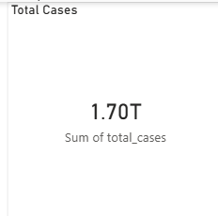
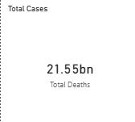
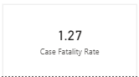

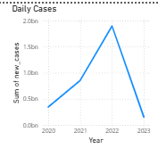

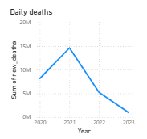

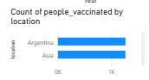
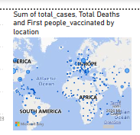
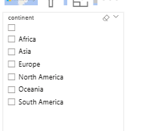
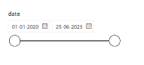
TABLEAU:
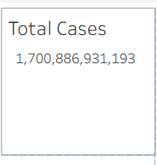
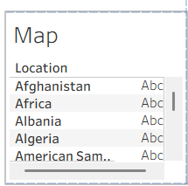

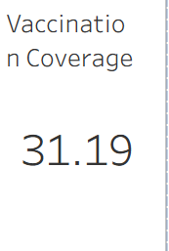
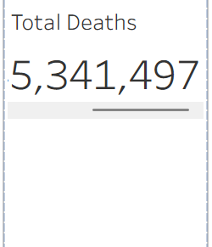
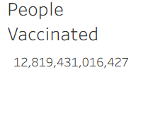
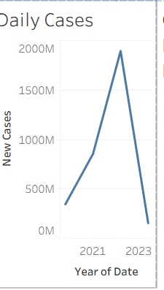
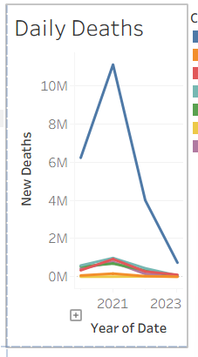
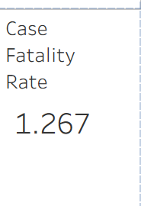
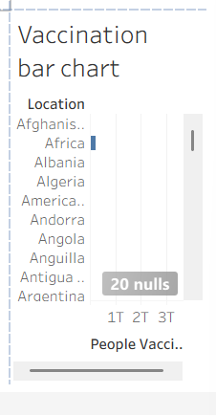

POST-LAB QUESTIONS (PROVIDE BRIEF ANSWERS TO THE FOLLOWING QUESTIONS)
  - How did data transformation improve the quality of insights in your COVID-19 dashboard?

Data transformation improved the dashboard by converting the data into the correct format, handling missing values, and creating calculated fields such as Case Fatality Rate and Vaccination Coverage. This made the data accurate, consistent, and suitable for meaningful analysis and visualization.

  - What challenges did you encounter during the data cleaning process, and how did you resolve them?

The main challenges were missing (null) values, incorrect data types, and inconsistent records. These issues were resolved by replacing or removing null values, converting the Date column to the correct date format, and ensuring all numerical fields were properly formatted before creating visualizations.

  - Which KPI provided the most valuable insight, and why?

The Vaccination Coverage (%) KPI provided the most valuable insight because it showed the percentage of the population that had been vaccinated. This helped compare vaccination progress across different countries and understand the overall response to the pandemic.

  - How does interactivity in dashboards improve user experience?

Interactivity allows users to filter data by country and date, explore different regions, and focus on specific information. Features such as slicers, filters, and interactive charts make the dashboard easier to use and help users gain insights quickly.

  - What steps would you take to further enhance the dashboard’s effectiveness?

The dashboard can be improved by adding more KPIs, including trend forecasting, using drill-through and drill-down features, applying conditional formatting, and displaying real-time COVID-19 data. Adding more interactive filters and informative tooltips would also improve the user experience.

GITHUB LINK:

RESULT:

The COVID-19 dataset was successfully cleaned, aggregated, and transformed for visual analysis using Tableau and Power BI. Missing values, data type mismatches, and inconsistencies were addressed. KPIs such as vaccination rate and daily case growth offered valuable insights into the pandemic trends across countries and timeframes. The resulting interactive dashboards allowed for effective public health monitoring and communication.

ASSESSMENT

Description |  | Max Marks | Marks Awarded
Pre Lab Exercise |  | 5
In Lab Exercise |  | 10
Post Lab Exercise |  | 5
Viva |  | 10
 | Total | 30
 | Faculty Signature

